Project Online to Altus Migration

Post Migration Checklist for the Client

March 2026
Table of Contents
Client Post Data Migration Checklist 3
1. Assign Ownership 3
Update the Project Manager Field for a Single Project 3
Bulk-update the Project Manager Field 4
2. Update Resources 5
Update a Resource Individually 5
Bulk-update Resource Fields 5
3. Create A Project Team Site 7
4. Move the Project MPP Schedule to the Project Team Site 9
5. Apply Project Dependencies 10
6. Review and update Project Risks and Issues 15
7. Update Project Registers 16
8. Review and update the linked Project Schedule using Altus for Project 17
9. Move required project documents into your new Project Team Site 20

Client Post Data Migration Checklist
The purpose of this post-migration checklist is to guide client stakeholders, primarily the PMO and Project Managers, through the key validation and readiness activities required immediately following the migration from Project Online to Altus PPM. It outlines the practical steps needed to review migrated project data, confirm core configurations, and ensure that projects, reporting, and day-to-day processes are functioning as expected within the Altus environment.

Assign Ownership
After migration completes, the Project Manager must be manually assigned to ensure appropriate permissions are received.

Update the Project Manager Field for a Single Project
- Navigate to Altus.
- Select Initiatives > Projects
- Search and Click on the name of the project to open it
- In the top right corner of the screen select the down arrow icon.
  - 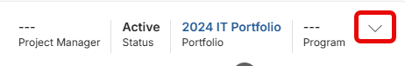
- Search for and select the correct name for the Project Manager
  - 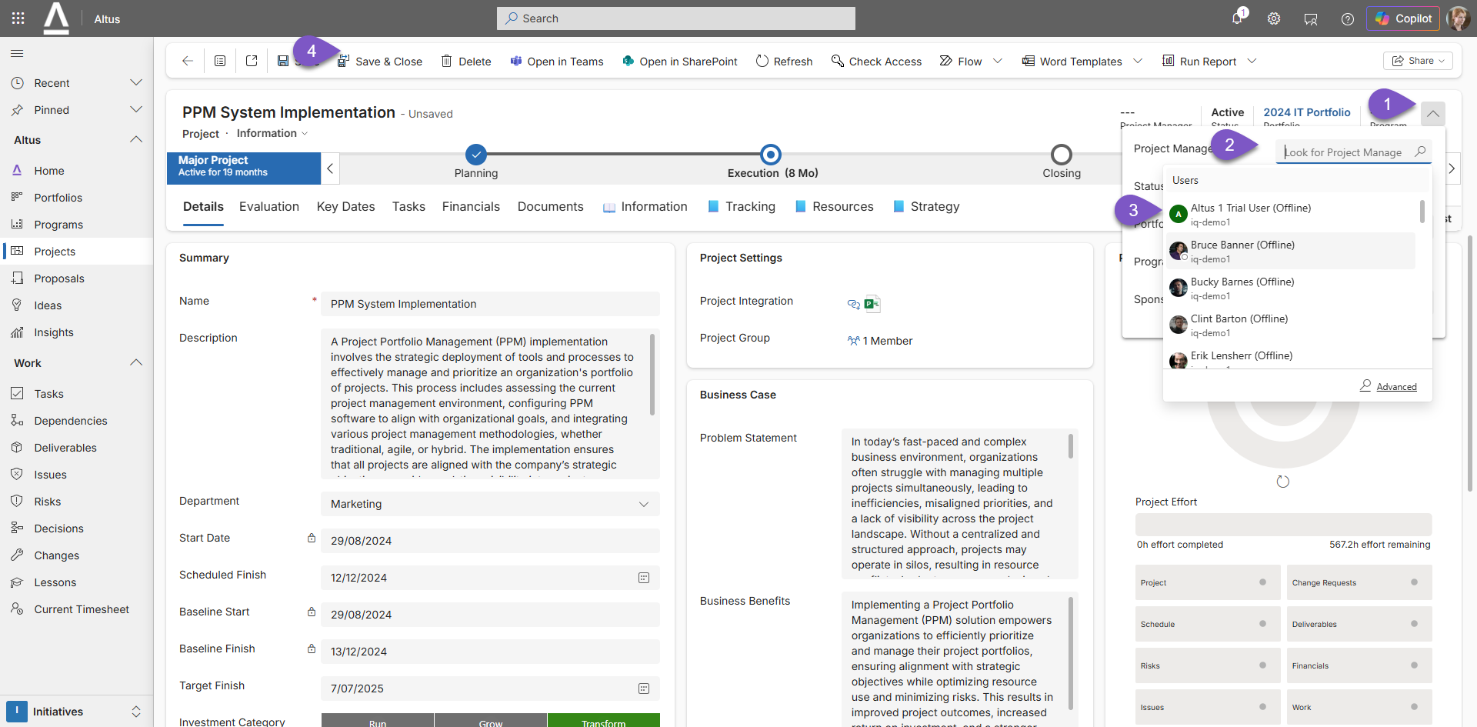
- Click the Save and Close button to commit your update.

Bulk-update the Project Manager Field
- Navigate to Altus.
- Select Initiatives > Projects
- Select Open in Excel Online from the Export to Excel menu bar item.
- Make the necessary updates to the Project Manager field, noting the exact syntax of that user’s name must match in Altus to prevent errors.
  - 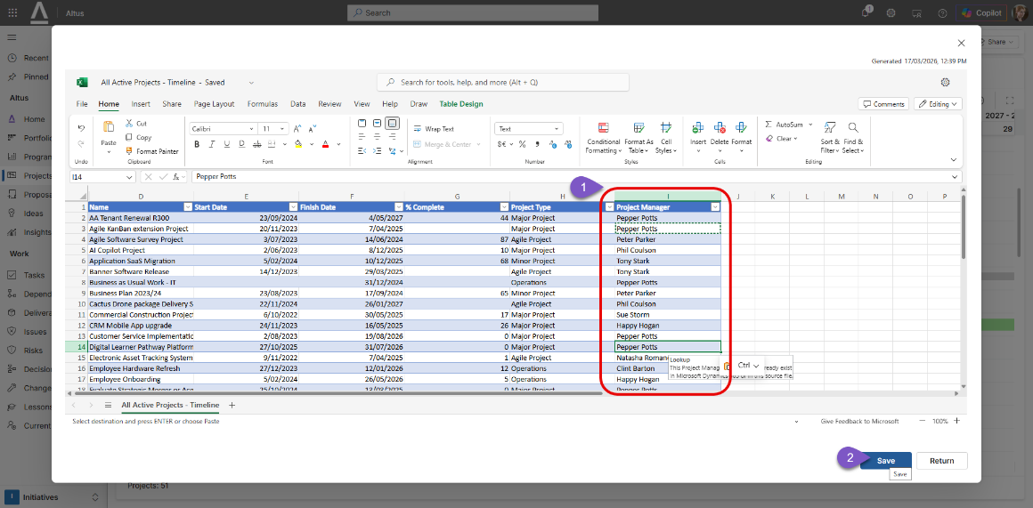
- Click Save to commit your updates.
- Track the progress of the update. Click refresh
  - 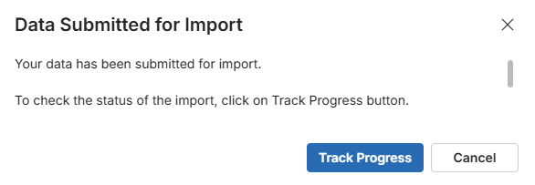
  - 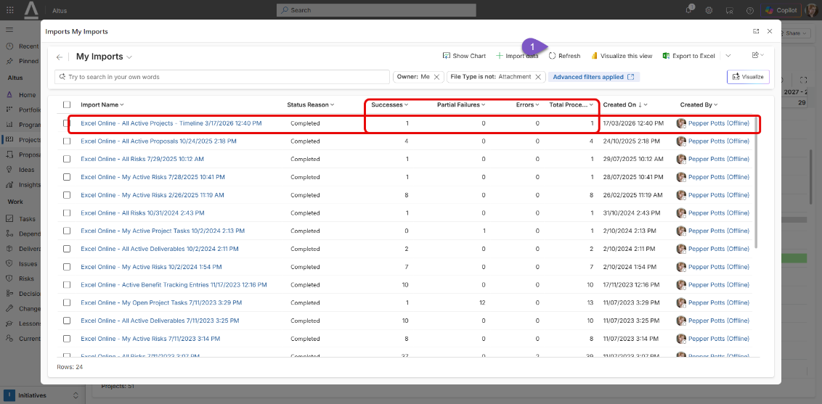

Update Resources
Review bookable resource data. Ensure attributes are assigned. Update additional Altus fields (Resource calendar, line manager, timesheet manager).

Update a Resource Individually
- Navigate to Altus.
- Select Resources > Resources
- Search and Click on the name of the resource to open it
- Make the necessary updates to the resource fields. For example, Line Manager, Default Cost Category, required to complete timesheet, Timesheet Manager
  - 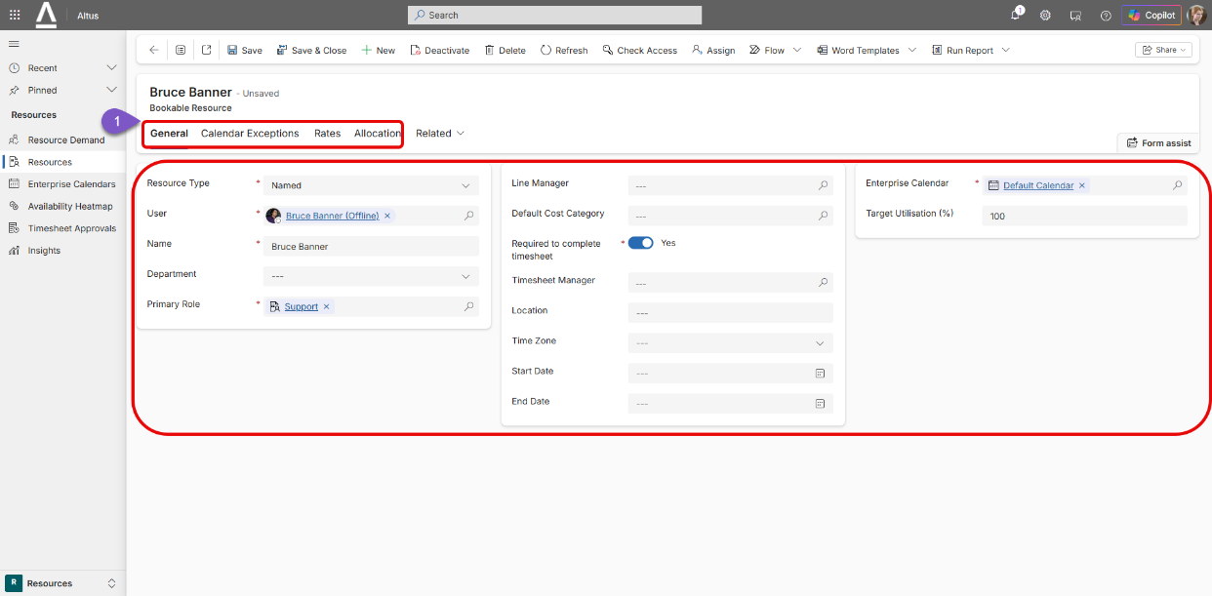
- Click the Save and Close button to commit your update.

Bulk-update Resource Fields
- Navigate to Altus.
- Select Resources > Resources
- Select Open in Excel Online from the Export to Excel menu bar item.
  - 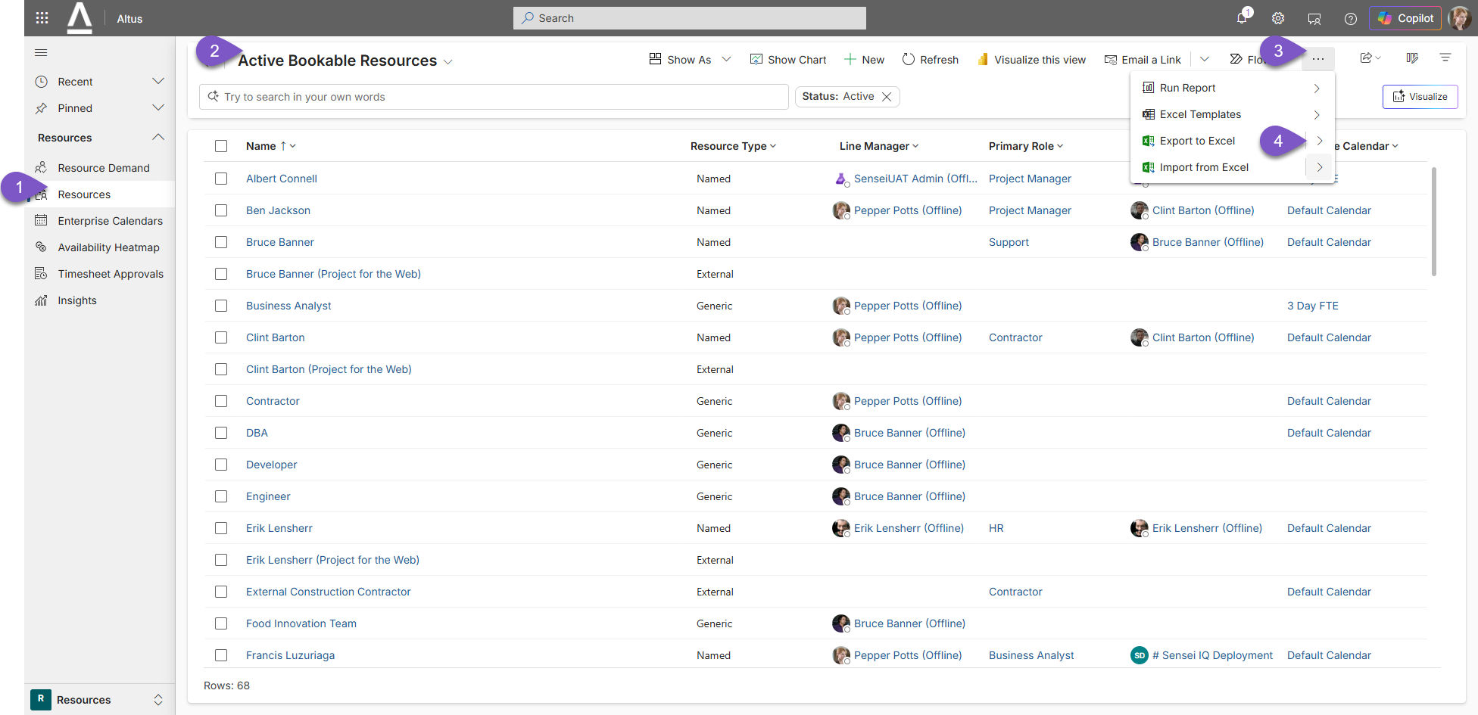
- Make the necessary updates to the Resource fields, noting the exact syntax of that value must match what Altus is expecting to prevent errors. An alternative option is to use a static Excel sheet to further assist with available drop-down values for example.
  - 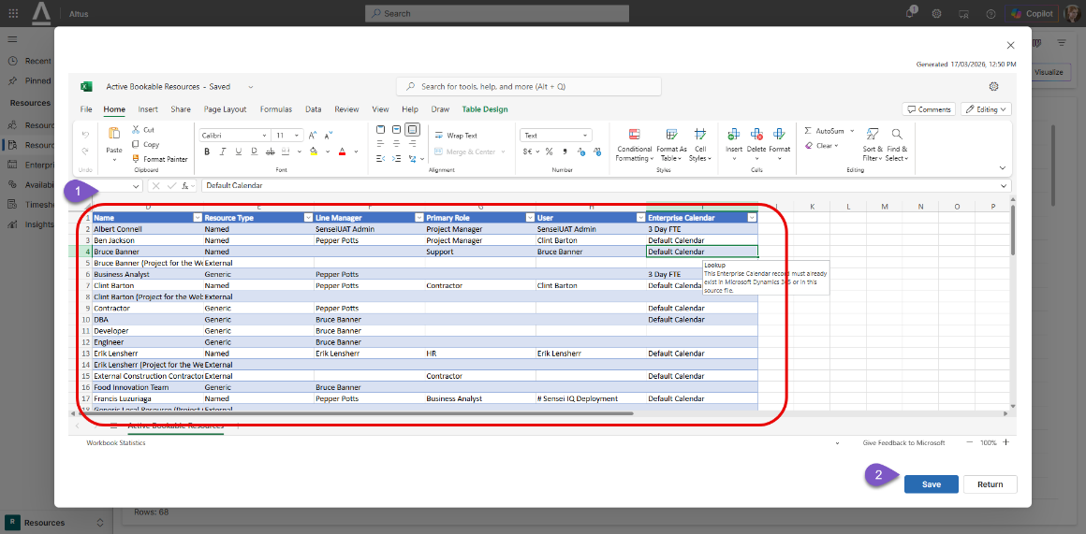
- Click Save to commit your updates.
- Track the progress of the update. Click refresh

Create A Project Team Site
Manually create connected Team Sites for Active/In-flight projects. Move appropriate project documentation into the associated Project Channel. Note, this process can only occur one at a time using the out of the box method described below.
- Navigate to Altus.
- Select Initiatives > Projects.
- Search and Click on the name of the project to open it.
- Under the Details tab, click on the No Group value of the Project Group field under the Project Settings section.
  - 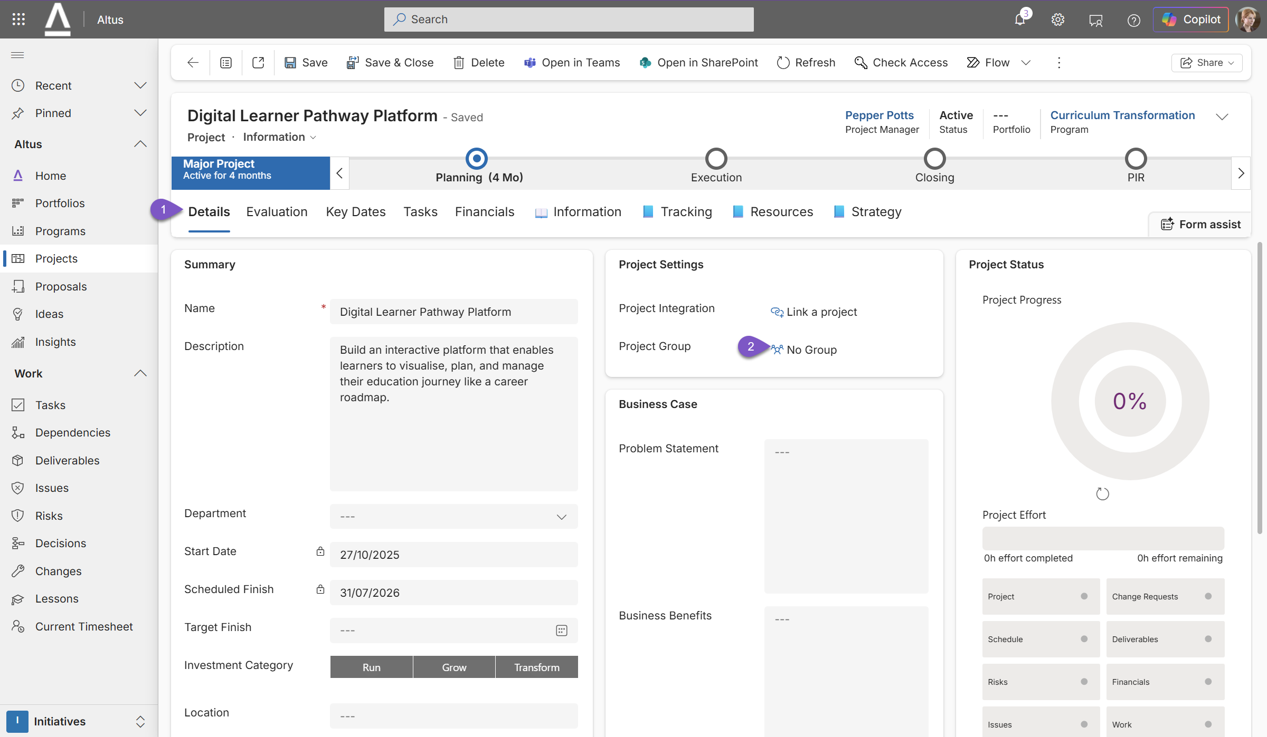
- Decide to either create a new group (Microsoft Team – option 1) or alternatively, link to an existing group (Microsoft Team – option 2)
  - 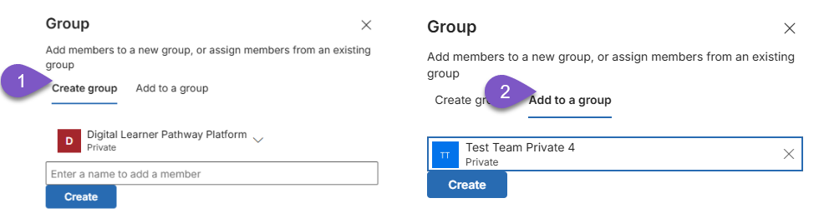
- Save the project. Once the Open in Teams button appears, click this to trigger the linking process between Altus and Microsoft Teams, essentially creating a new channel within your team site, named the same as your project name or as specified in the last step. Give the process a minute or so to initiate and make the one-off linkage.
  - 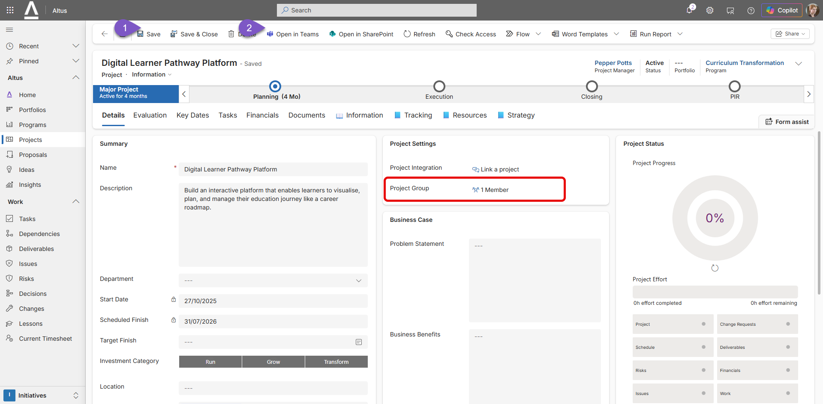
- You will then arrive at the linked Team.
  - 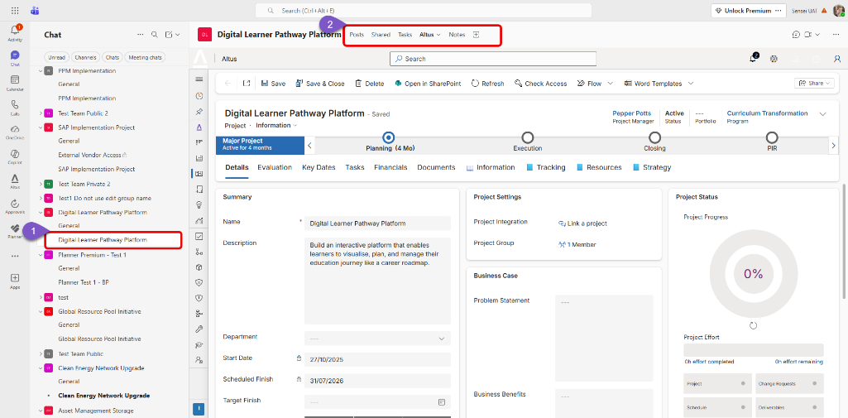
- Navigate to Shared Tab. This is the same location a newly linked team site is pointing to when you see the Documents tab inside the Altus Project.
  - 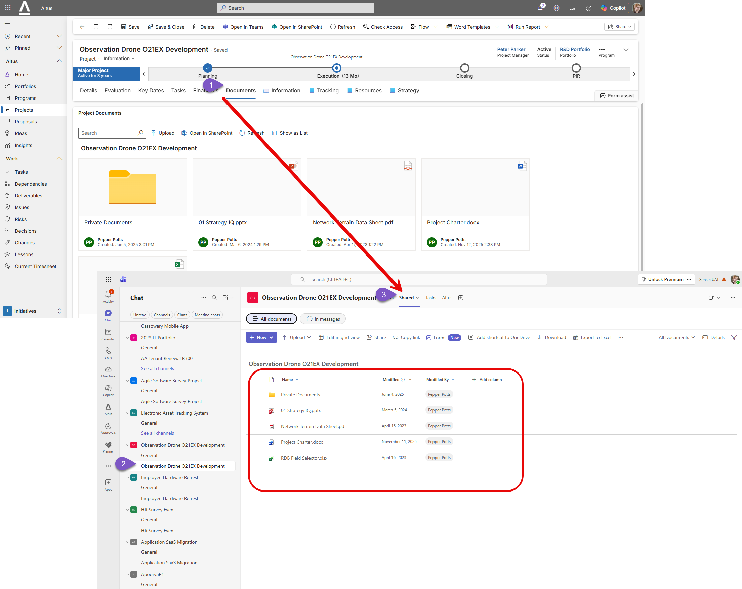
- From this location, load any required project documents from your previous location. If using the Altus for Project Add-in, ensure you store your Project Desktop MPP file in this location as it contains version control through SharePoint and offline/online file synchronisation capability through Microsoft OneDrive.

Move the Project MPP Schedule to the Project Team Site
Manually move the associated project schedule (MPP file) into the associated Project Channel SharePoint Library for Active/In-flight projects.
- Navigate to your connected project team Site.
- Navigate to Shared Tab. This is the same location the linked team site is pointing to when you see the Documents tab inside the Altus Project. Alternatively you can upload your MPP schedule file directly through this tab within Altus.
- From this location, load any required project documents from your previous location. If using the Altus for Project Add-in, ensure you store your Project Desktop MPP file in this location as it contains version control through SharePoint and offline/online file synchronisation capability through Microsoft OneDrive.

Apply Project Dependencies
Manually assign predecessor or successor relationships between individual projects if you want to represent inter-project dependencies in Altus.
Review the content on this topic under the Altus Help Centr: https://help.altus.pro/en/article/creating-dependencies-between-projects, shown below for convenience.
In Altus, your organisation can visualise and manage dependencies across your entire portfolio or program of inter-related projects to help you understand how project timelines align, identify risks and blockers early, see how delays in one project could impact others and gain a complete picture of your project flow — all in one place.
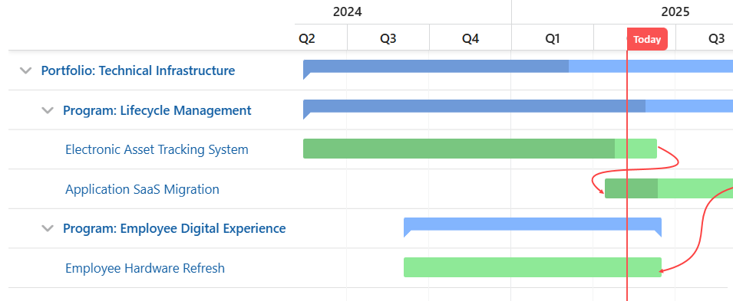
The following dependency types can be created:
- Finish-to-Start (FS): The successor project cannot start until the predecessor project finishes.
Example: Project B cannot start until Project A is completed.
- Start-to-Start (SS): The successor project cannot start until the predecessor project starts.
Example: Both projects need to start together.
- Finish-to-Finish (FF): The successor project cannot finish until the predecessor project finishes.
Example: Both projects need to finish at the same time.
- Start-to-Finish (SF): The successor project cannot finish until the predecessor project starts.
Example: Project A cannot finish until Project B begins.
Create a predecessor dependency between projects
- Within a project record, navigate to the Dependencies tab under the Tracking section.
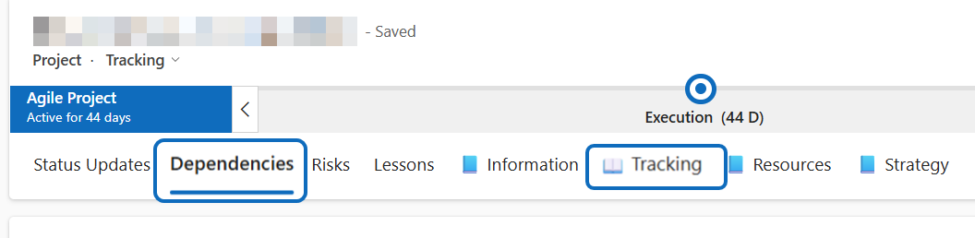
- Under the Predecessor Dependency section, click + New Dependency.
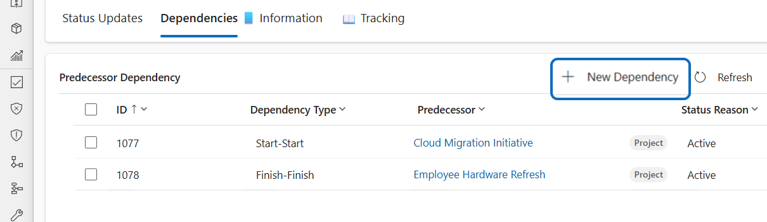
- Using the New Dependency form, choose the appropriate option from the Dependency Type drop-down menu.
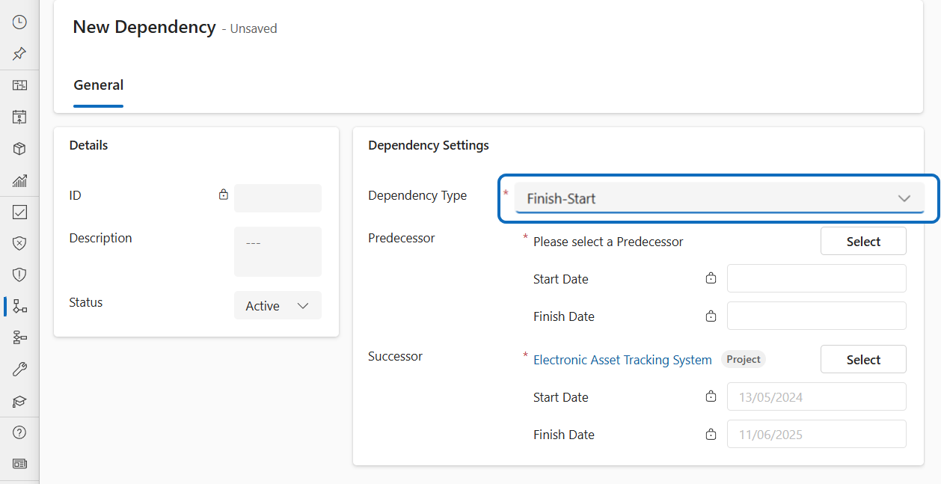
- Select the other project that your current project, the Successor, is dependent on as its Predecessor project and click Apply Predecessor.
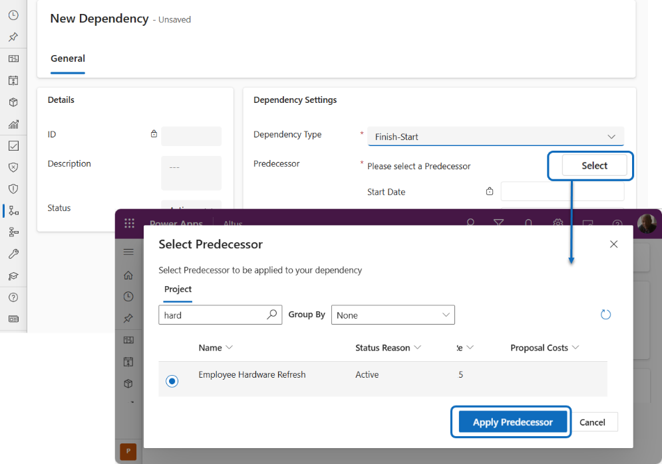
- Once linked, click Save and Close to create the dependency.
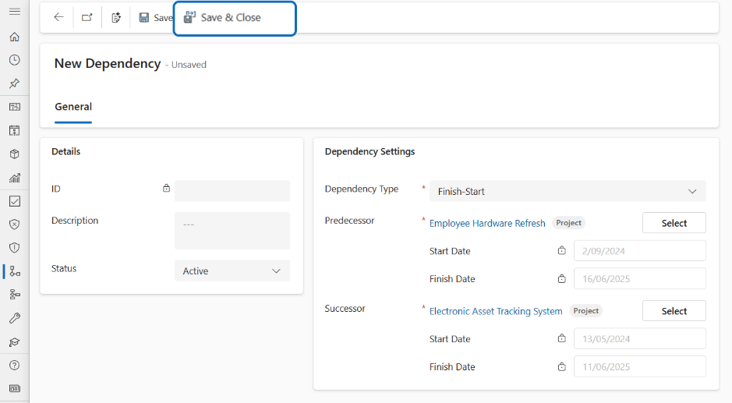
Create a successor dependency between projects
- Under the Successor Dependency section, click + New Dependency.
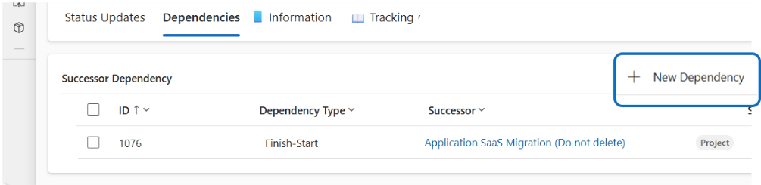
- Using the New Dependency form, choose the appropriate option from the Dependency Type drop-down menu.
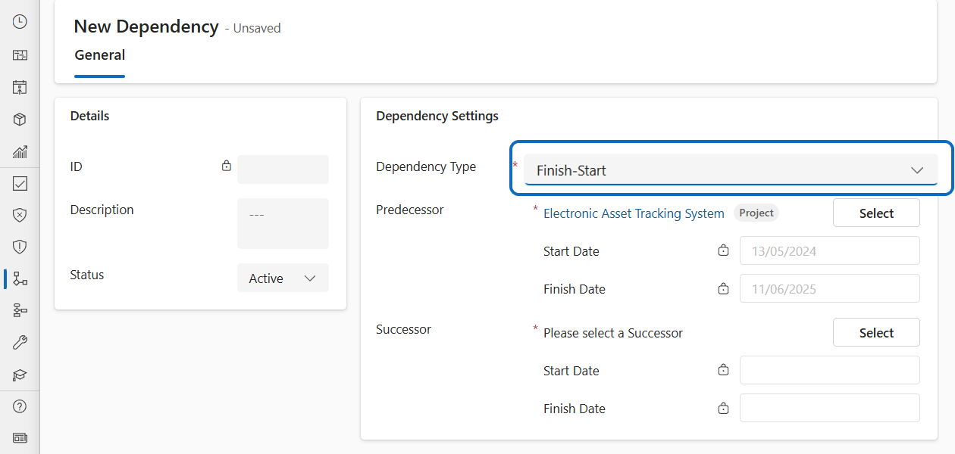
- Select the other project that is dependent on your current project, the Predecessor, as its Successor project and click Apply Successor
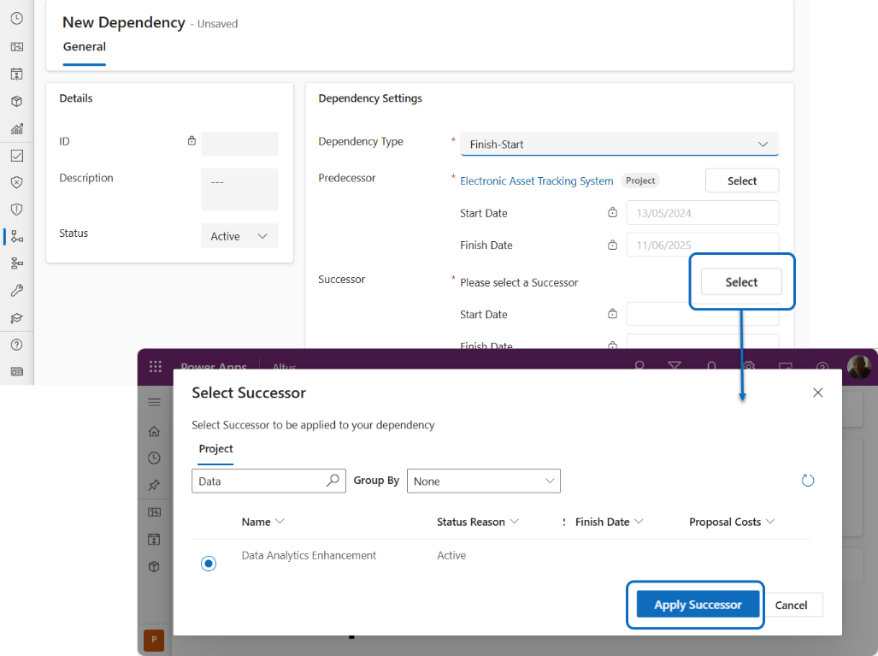
- Once linked, click Save and Close to create the dependency.
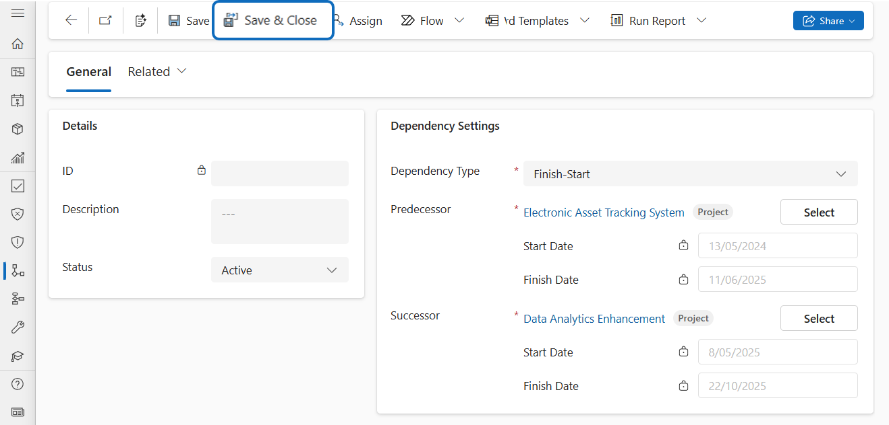
View interproject dependencies
- You can view the list of active interproject dependencies under the Dependency tab of a project record.
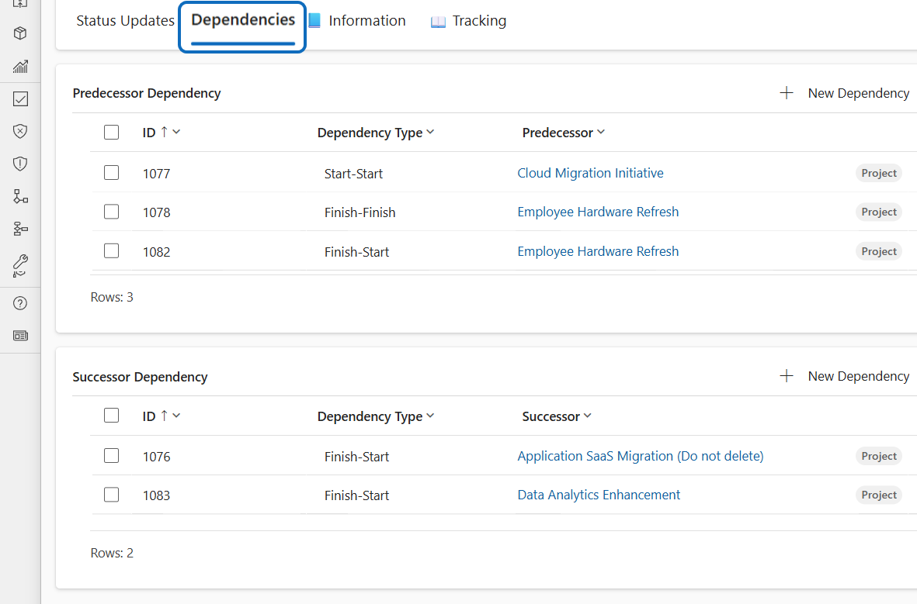
- You can view the list of all active interproject dependencies in the system via the Dependencies option from the left navigation menu.
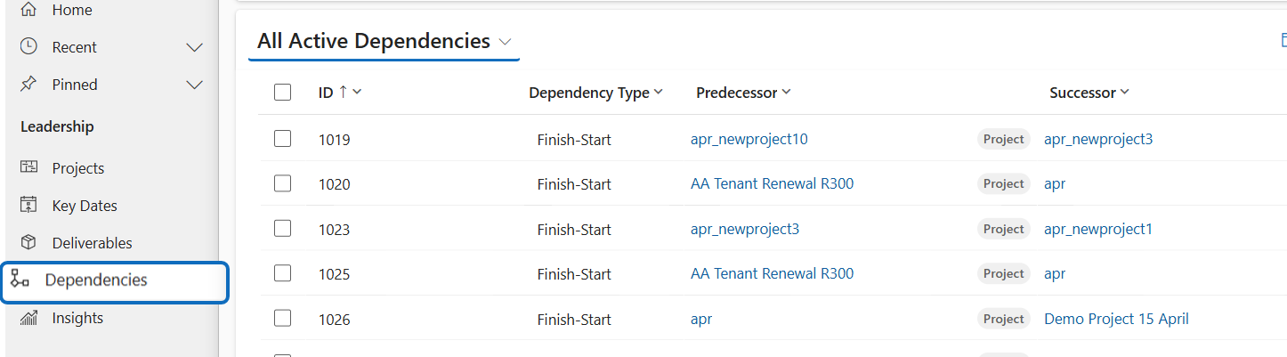
- You can view the active interproject dependencies under the Projects tab of the portfolio or program record that the project is associated to.
  - 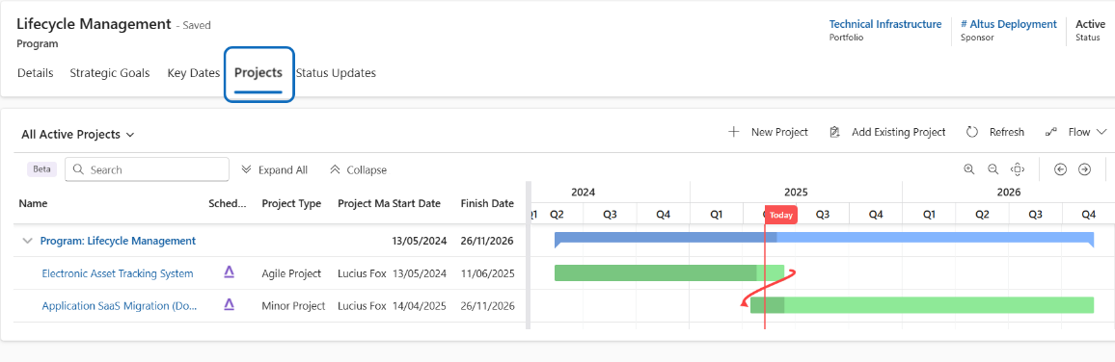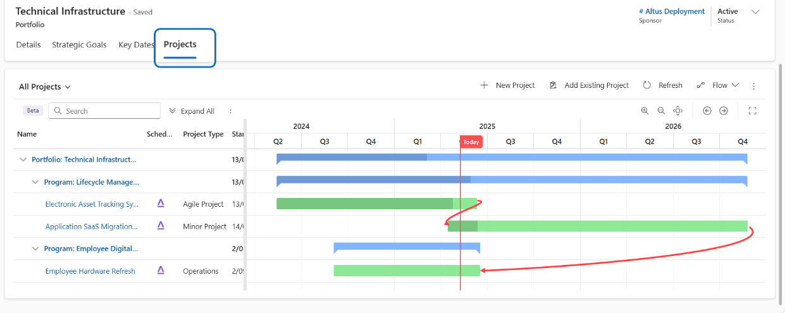

Review and update Project Risks and Issues
If risks and issues are identified in your specific Project Online to Altus data migration project, then consider this review step. The migration team would have decided which fields to migrate and map to in the Altus risk and issue registers. Some fields may have been identified as out of scope and some fields in the out of the box Altus registers may have been left in. We recommend reviewing this information and making any necessary updates to the system as directed by your PMO/internal team.
- Navigate to Altus.
- Select Initiatives > Projects
- Search and Click on the name of the project to open it
- The default project experience in Altus has project specific register information under four areas, Information, Tracking, Resources and Strategy. When you click on one of those sections with a blue book icon in front of them, it will expose the enabled project registers for that section. The current group enabled is represented with an open book icon
  - The Risks and Issues registers are located typically within the Tracking tab
  - 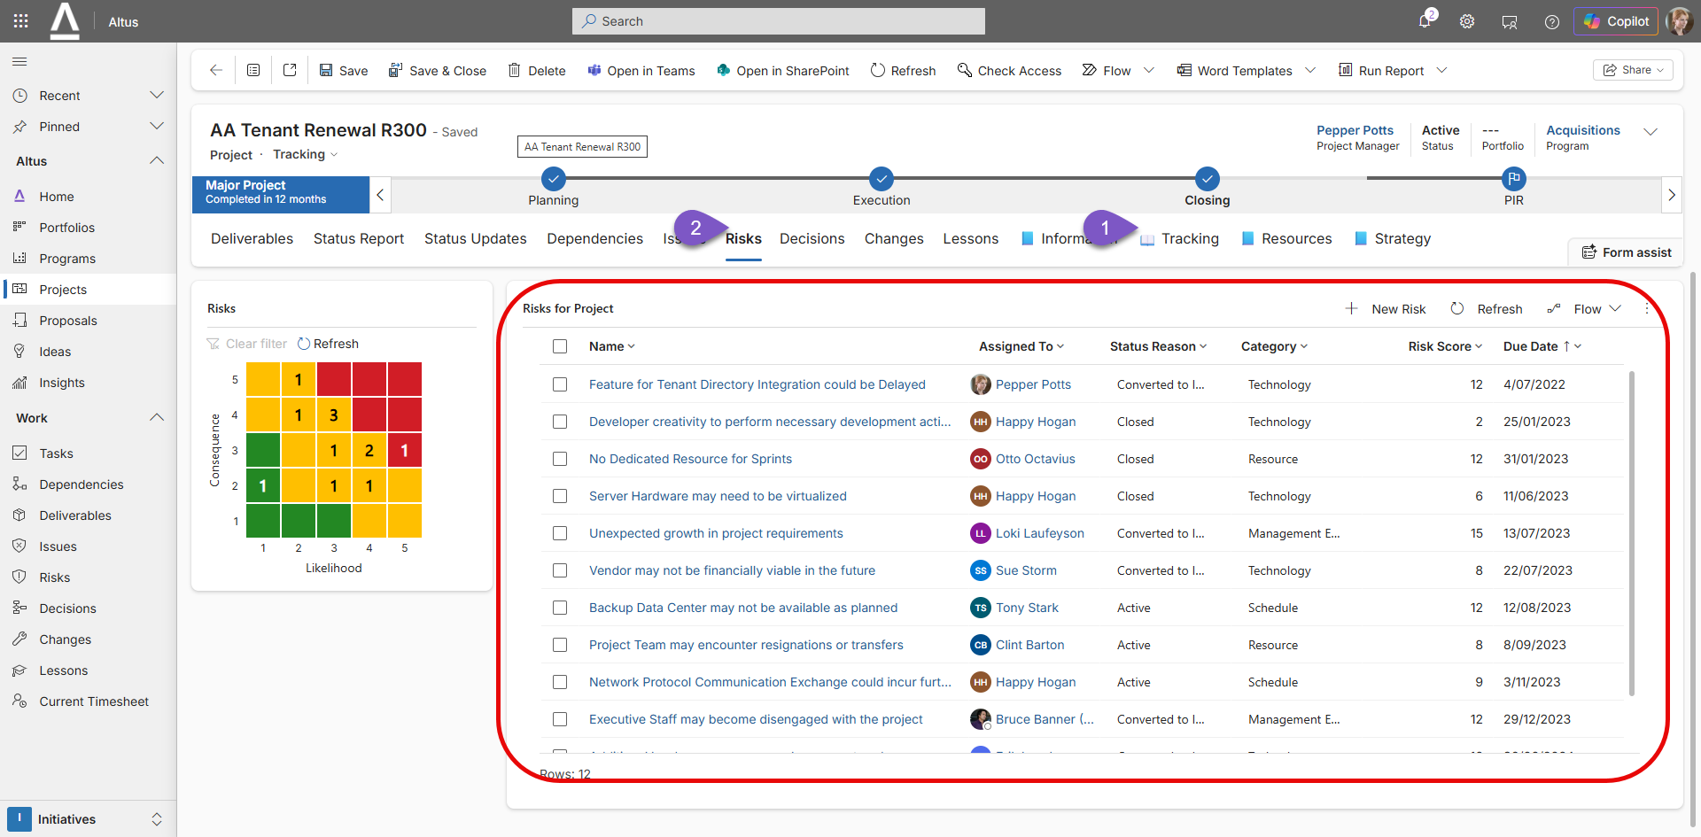
  - 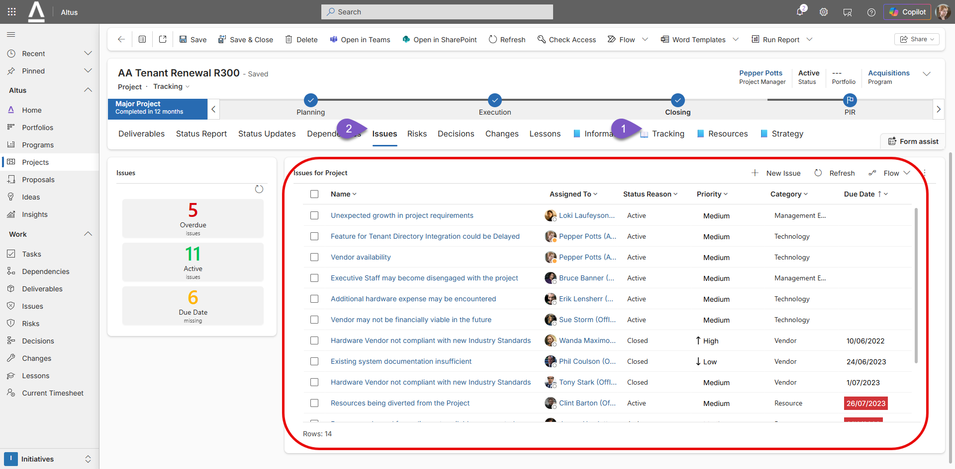
- Review the migrated information on each of those registers (tabs) and make any necessary updates to the system as directed by your PMO/internal team.

Update Project Registers
Altus ships with some out of the project registers that your organisation may have enabled for your project type in the system. Review and update any associated Project register information for your project as appropriate. Seek guidance from your internal Project Management Office team on expectations and how this information will be used and reported on internally.
- Navigate to Altus.
- Select Initiatives > Projects
- Search and Click on the name of the project to open it
- The default project experience in Altus has project specific register information under four areas, Information, Tracking, Resources and Strategy. When you click on one of those sections with a blue book icon in front of them, it will expose the enabled project registers for that section. The current group enabled is represented with an open book icon
  - What you can see within these specific areas will depend on the project type settings set by your administrator. The example below shows the Details, Evaluation, Key Dates, Financials and Documents tabs available when clicked on the Information Group Tab:
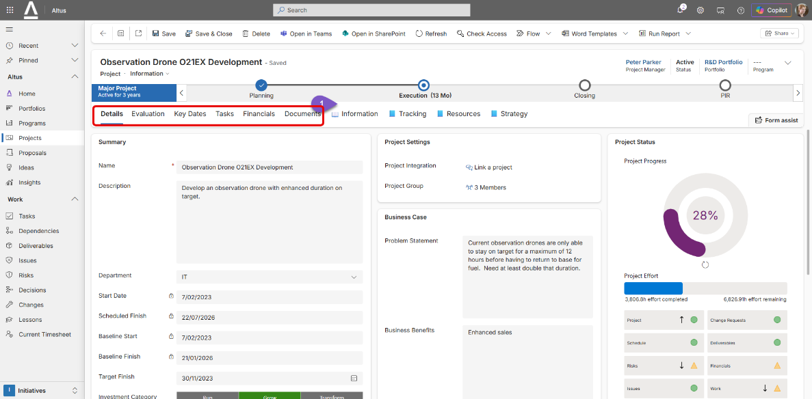
- Click on each tab for each section of the project and get a feel for the type of information it can store. Complete and update the registers as directed by your internal Project Management Office team on expectations and how this information will be used and reported on internally.

Review and update the linked Project Schedule using Altus for Project
Review, update and publish schedules to confirm they are production ready. Consider re-baselining if appropriate to account for variances.
- This procedure assumes you are using the Altus for Project Add-on and the project MPP schedule is already connected to your Project in Altus.
  - Altus for Project Add-in Deployment
    - https://docs.altus.pro/products/AltusForProject/Deployment.html?tabs=Admin%2CGA
  - Altus for Project Help
    - https://docs.altus.pro/products/AltusForProject/Help.html
- Open your connected Project Schedule file (.MPP), noting ideally, this should be safely stored in your connected Microsoft Team site for version control purposes as described in the ‘Move the Project MPP Schedule to the Project Team Site’ section of this document.
- Everything in your schedule should be preserved as per your last migrated schedule version from Project Online noting the following points of difference to review and consider:
  - Resource Calendars are not a one-to-one match in Project Online so they may slightly vary the work contouring of that resource. As an example, Altus allows you to create a global resource calendar and specify how many hours to apply a day for a working week of a resource, then choose which days a resource is working. Project Online however has a slightly more granular resource calendar feature that lets you specify the hours per day.
    - 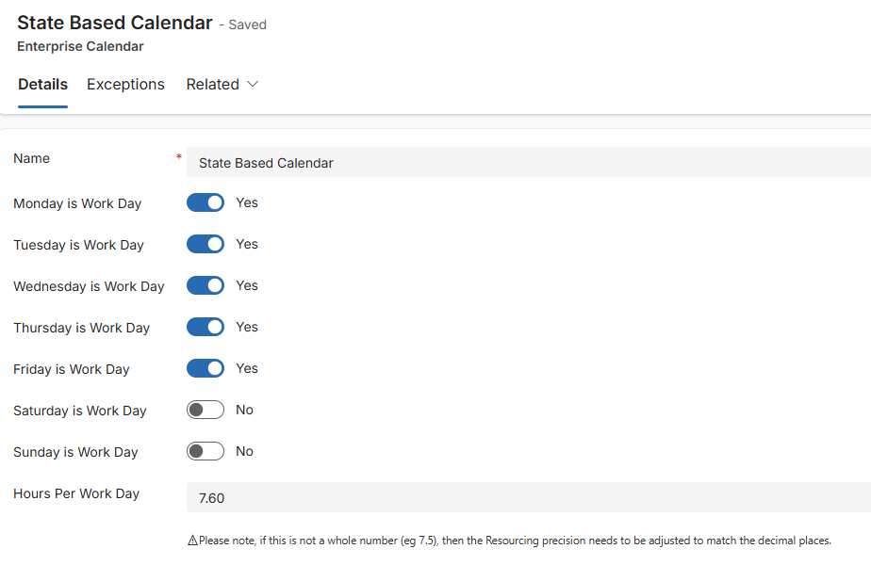
  - Inactive resource will not have been migrated into Altus so they will show up in your MPP file as local resources, not mapped to Altus, therefore not reportable in Altus reporting.
  - Previously Project Online specific task custom fields will no longer appear after the migration. Due to technical limitation, the Task Custom fields have been mapped to a specific set of mapped local task custom fields. Check with your local PMO/Altus Administrator on what those mappings are. For example, a task custom field in Project Online named Milestone Category may have had 5 values in a drop down previously. If identified as a field to migrate, this would now likely map to a project custom field
    - 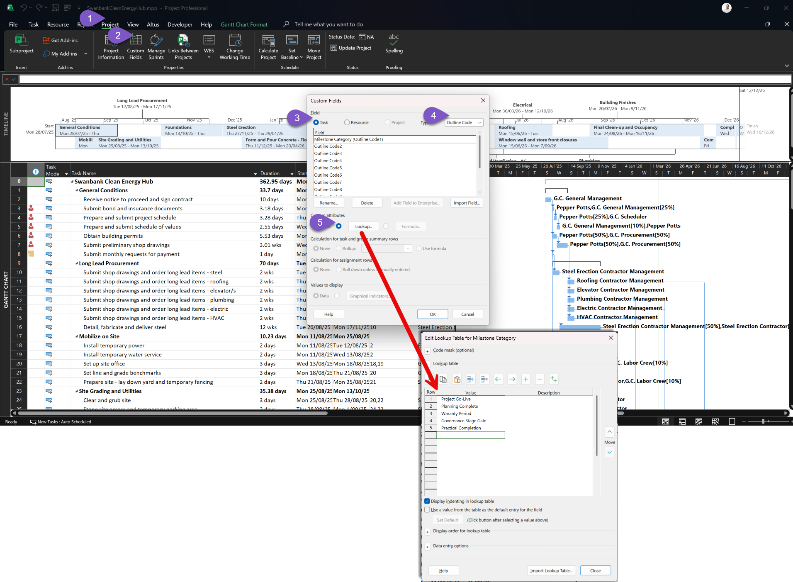
  - Add the appropriate replaced Task custom fields to your required project views
  - Save and Publish the MPP file to save the mapped information back into Altus.
    - 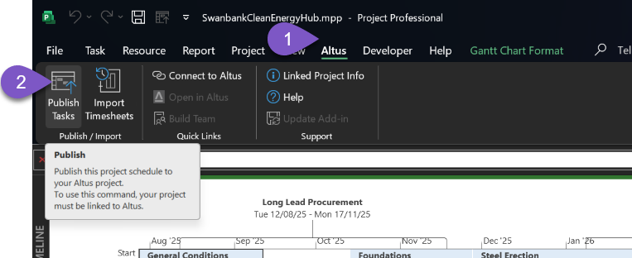
    - 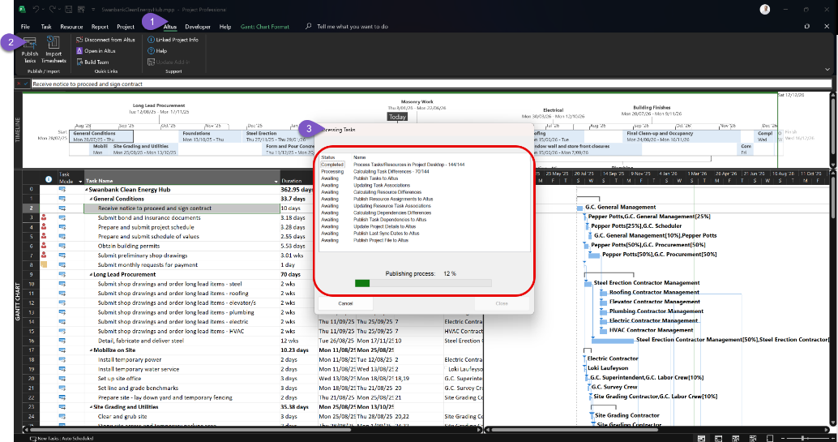
    - 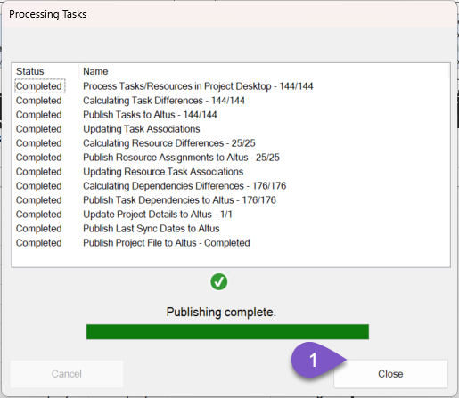
  - Be aware not all information in the Project Desktop is being sent to Altus. Altus contains a central configuration setting for all Project Desktop files which indicate specifically which fields are being captured and mapped back to the central Altus task table. Be familiar with what information is being captured and how that information is being used and reported on by your organisation. Below is an example of the default project field mappings to the Altus for Project Desktop add-in as an example, noting this can be extended and you may likely have an organisational specific setting in place already:
    - 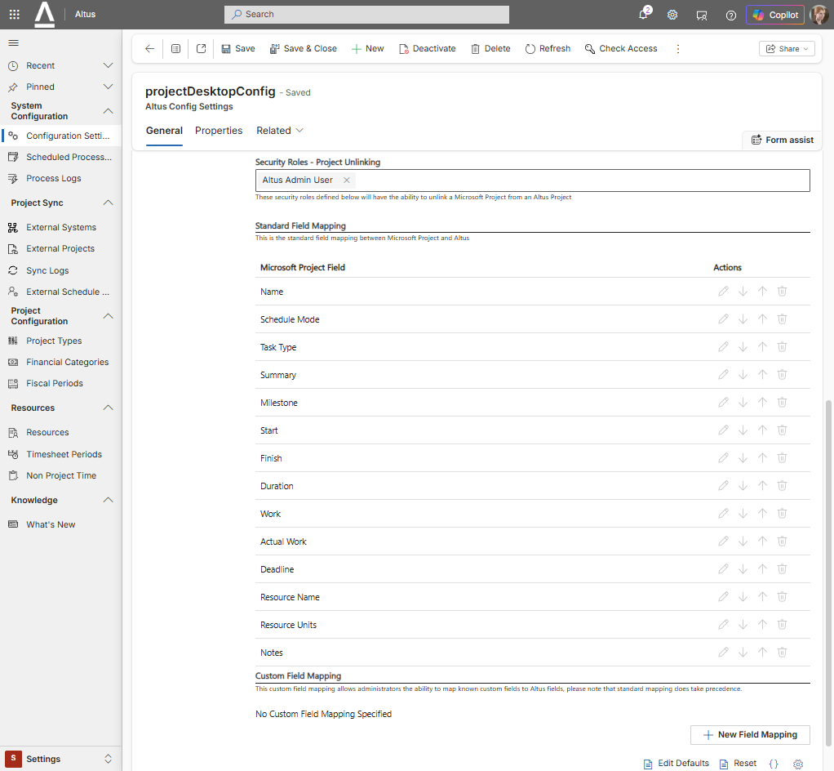

Move required project documents into your new Project Team Site
If project documents were identified as in scope in your specific Project Online to Altus data migration project, then consider this review step, particularly for in-flight projects. The migration team would have decided which projects to migrate into Altus. Due to technical limitations and differences between the old and new PPM platforms, the migration team have had to export the documents into a central SharePoint site within your Microsoft 365 tenant. If your project contained documents, a folder would have been created in this central site.
We recommend reviewing this information and manually migrating any necessary documents to your project team site as directed by your PMO/internal team.
- Navigate to your connected project team Site.
- Navigate to Shared Tab. This is the same location the linked team site is pointing to when you see the Documents tab inside the Altus Project. Alternatively, you can upload documents directly through this tab within Altus.
- From this location, load any required project documents from your previous backed up document location. In doing so you will be taking advantage of the native SharePoint version control and offline/online file synchronisation capability through Microsoft OneDrive.

